**PROGRAMMING ASSIGNMENT 2 – Ankit Nashine**

**1) Using google collab. Installing tensorflow. Version 2.4.1**

**Installing Libraries**

**2) Loading the full data for Titanic (will split it into test and train later)**

**3) Exploratory analysis of the data**

**Graphs outlining nature of attributes**

**4) Data cleaning (created a new dataframe df with only those columns that are useful for analysis and dropping null rows)**

**Creating dummies for embarked and changing datatype**

**Pairplot to show the relationship for combination of variable**

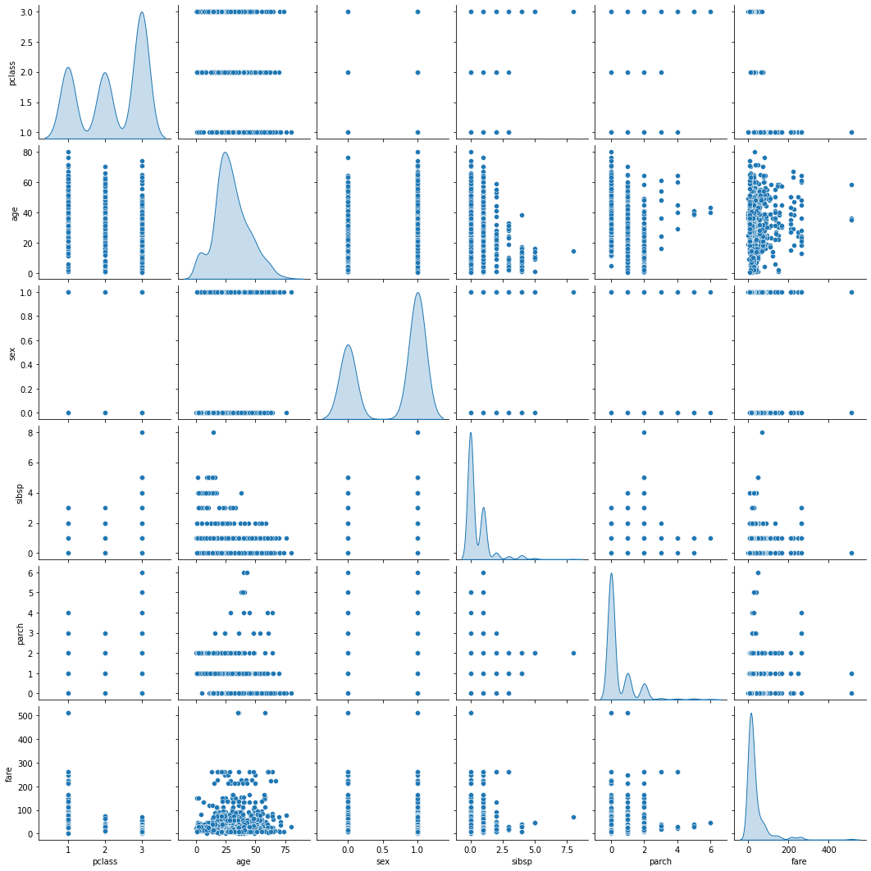

**6) Visualizations with finalized data (df)**

People with higher fare have more survival rate.

Children under 10 have better survival rate and people aged between 20-30 have highest death rate.

Parch 1, 2, 3 have higher survival rate and others have higher death rate (0 being highest)

sibsp 1 have higher survival rate and others have higher death rate.

Embarked C have higher survival rate, others have high death rate.

Females have higher survival rate whereas men have higher death rate.

Pclass 1 passengers have high survival rate whereas class 3 have lowest survival rate.

**Partitioning data for training and testing.**

**Preprocessing data to use in models**

**5) Try few different models.**

* Creating and compiling tensorflow keras ANN.

* Training Neural Network model and checking run time of model.

Model accuracy is 81.68% and runtime is 52.39 seconds.

**Checking accuracy on test set.**

**Other models building**

**Training accuracy of other models and time.**

**Testing accuracy**

**Variable importance**

**6. Would you {and an assumed passenger e.g Woman / 30 year old} survived the trip?**

Based on the graphs above a woman has a high chance of survival whereas 30-year-old has less chance of survival. Based on variable importance chart a page before, age had more importance so considering age, the chance of survival is slightly less than death chance.

Predicting my and jack rose survival (assuming values for my) using ANN and Random Forest (as it has good testing and training accuracy among all)

This model gives me just 3.9% survival chance whereas for jack its 12.7% and rose its 91.8%.

**7. Short write-up [1 page] of you findings in layman terms... who survives .. who dies.**

Based on visualizations in { 6 - Visualizations with finalized data (df) }

a) it is very clear that females are more likely to survive and men are more likely to die.

b) based on fare, high fare passengers (>50) are more likely to survive and less fare passengers are more likely to die.

c) People with age less than 10 and greater than 50 are more likely to survive and between 10 and 50 are more likely to die.

d) Parch 1, 2, 3 have higher survival rate and others have higher death rate (0 being highest).

e) sibsp 1 have higher survival rate and others have higher death rate.

f) Embarked C have higher survival rate, others (s, Q) have high death rate.

g) class 1 passengers have high survival rate whereas class 3 have highest death rate.

**Which combination of attributes is best?**

Old – Female – Embarked C – Class 1 passenger/high ticket fare – sibsp 1 – parch 1